Installation of Questa Sim:

In this installation the Pulpissimo is builded on Ubuntu 22.04 (for 24.04 version python libraries may work)

FYR: “https://github.com/pulp-platform/pulpissimo” Indepth details can be found in this directory

Step 1: Download the Questa Starter Pack

1. Go to the official Intel/Altera download page:
https://www.altera.com/downloads/fpga-development-tools/quartus-prime-lite-edition-design-software-version-25-1-linux

2. Select:
- Quartus Prime Lite Edition
- Choose Linux version
- Download the installer file
- Select the Individual files:

- Download Questa*-Altera FPGA and Starter Editions:
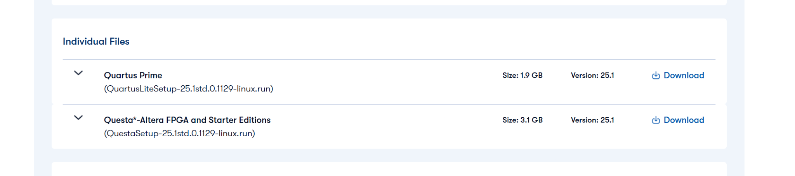

3. After download, extract the file:
- cd ~/Downloads
- chmod +x QuestaSetup-25.1std.0.1129-linux.run
- ./QuestaSetup-25.1std.0.1129-linux.run

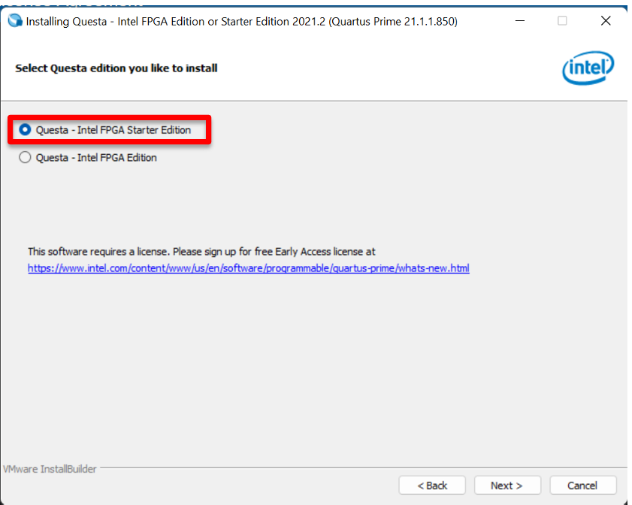

Step 2: Generate the License File
- Go to the Self-Service Licensing Center (SSLC):
https://www.altera.com/SSLC

- Register/Login to your account.(use your preferred email address)
- Select: Sign up for Evaluation or No-Cost Licenses


- Select the Questa*- FPGA Starter Edition (License SW-Questa)
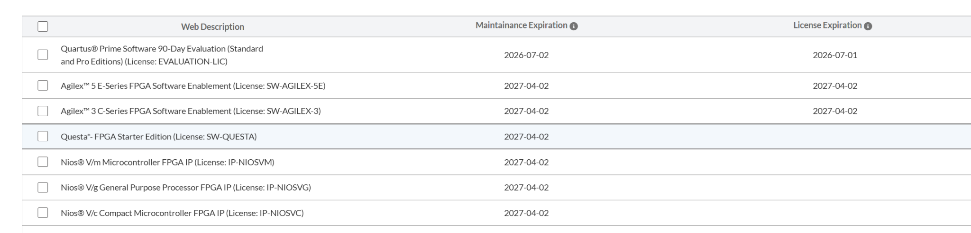
- Go next
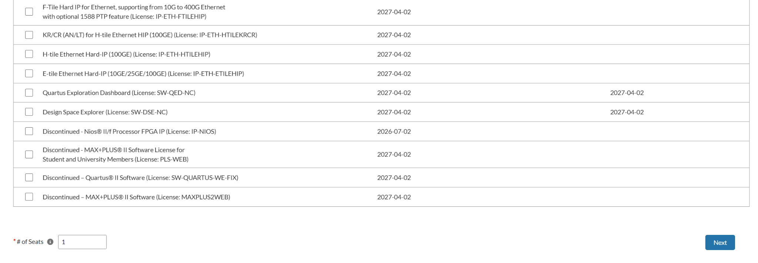
- Click on +New Computer
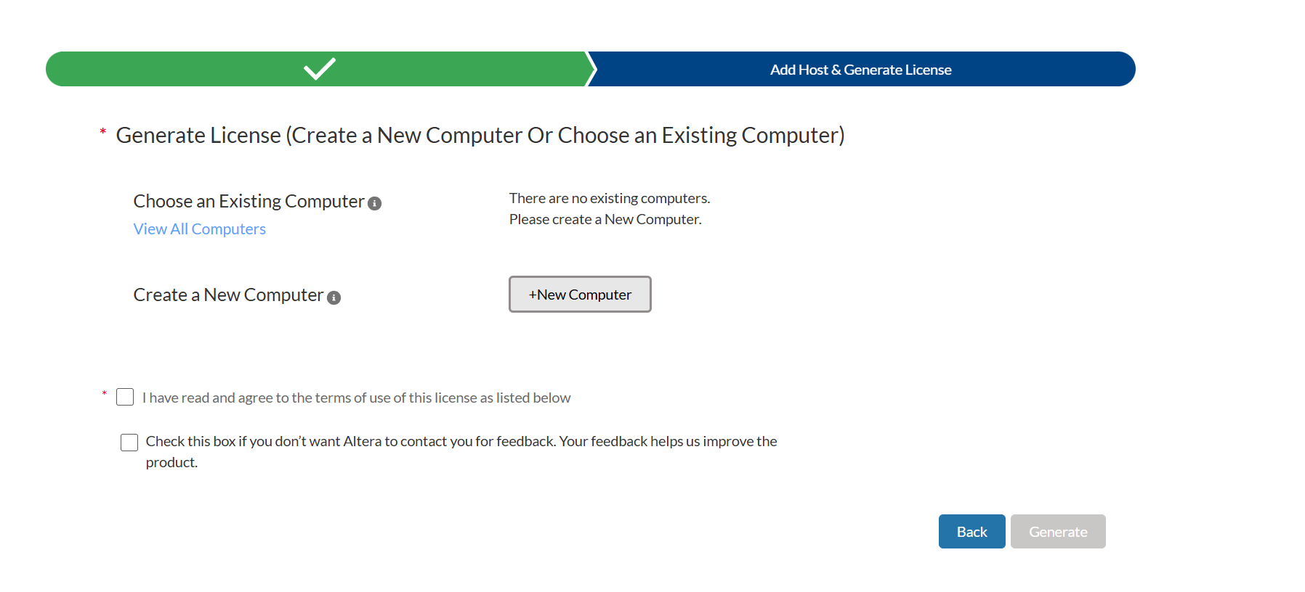
- Enter the following details
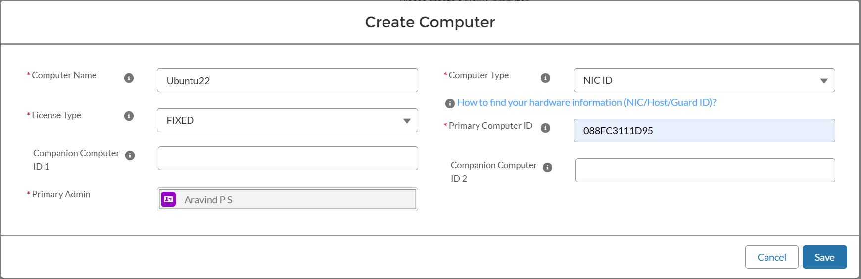
  - Computer Name: VM name
  - Licence Type: Fixed
  - Computer Type: NIC ID
  - Primary ID: copy from terminal using the following commands
    - Open terminal in VM:
    - Type ⇒ ip link and take the ethernet IP address (remove the semicolon from the IP address to enter to the)
OR
    - Take the MAC address from the VM settings (in pictures it might be different)
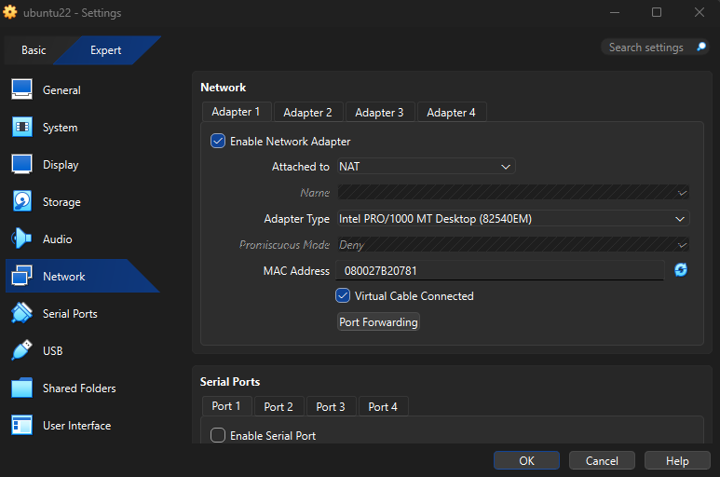
- Generate the License file by accepting the terms and conditions
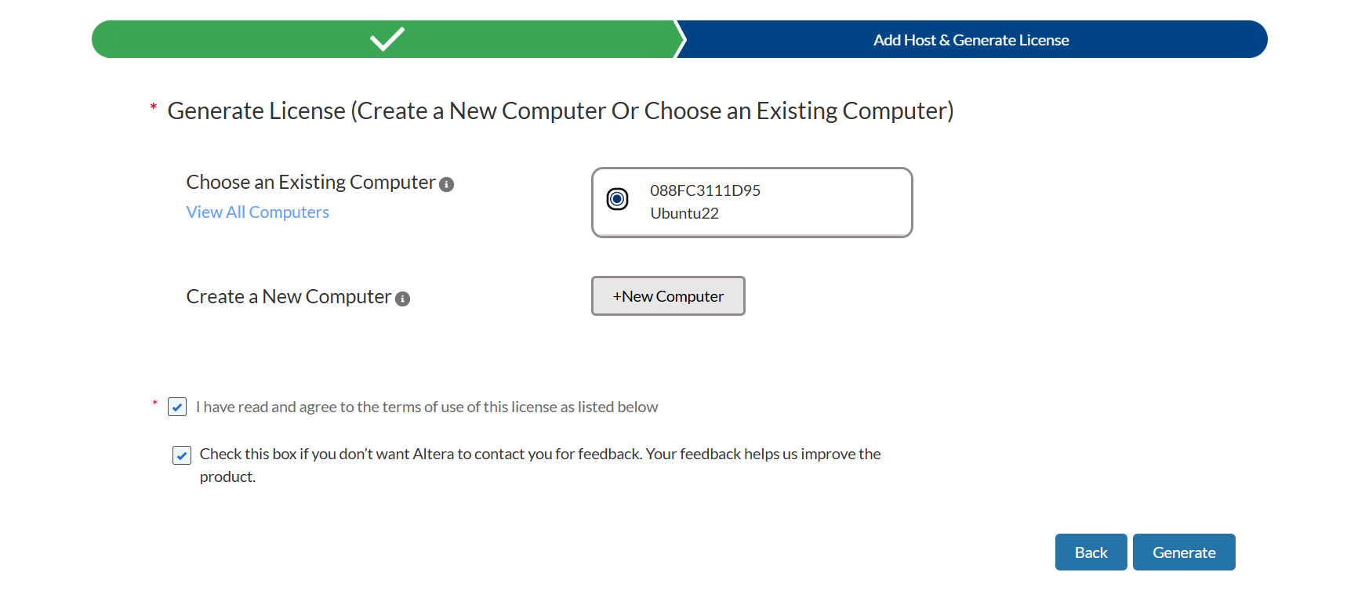
- License file will be sent to your email address and Download the attachment:
- Make sure the License is generated is similar to the one given below:
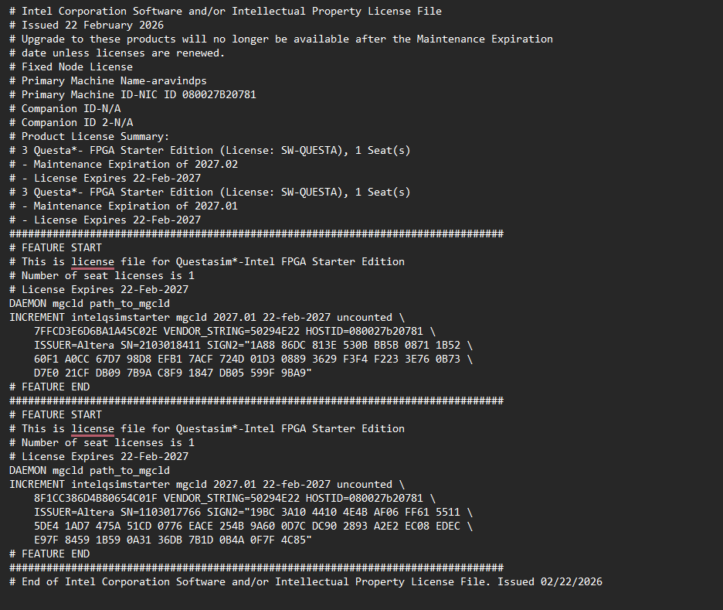

Step 3: Set License Environment Variable

Open .bashrc:
- export PATH=/home/user/altera/25.1std/questa_fse/bin:$PATH
- export SALT_LICENSE_SERVER=/home/<path to the file>/<License file name>.dat

PULPissimo V7.0 build

- git clone --recursive https://github.com/pulp-platform/riscv-gnu-toolchain.git

Install dependencies:

sudo apt-get install autoconf automake autotools-dev curl libmpc-dev libmpfr-dev libgmp-dev gawk build-essential bison flex texinfo gperf libtool patchutils bc zlib1g-dev

Make directory and Change the ownership to user
sudo mkdir /opt/riscv
sudo chown -R $USER:$USER /opt/riscv
(directories for the risc-toolchain)

Installation of the tool chain:

cd riscv-gnu-toolchain
# config
./configure --prefix=/opt/riscv --with-arch=rv32imc --with-cmodel=medlow --enable-multilib
# make
make

The make command may take time to install around 1 hr or more (based on system capability)

Add path to the .bashrc
Use the editor of your choice
# add path
export RISCV=/opt/riscv
export PULP_RISCV_GCC_TOOLCHAIN=$RISCV
export PATH=$PATH:$RISCV/bin

Installation of PULPISSIMO
Requirement:

If using Ubuntu 24.04 follow these steps:
sudo apt install python3-venv python3-full
python3 -m venv .venv
source .venv/bin/activate
python -m pip install --upgrade pip
pip install pyyaml
pip install semver==2.13.0

If using older version pf Ubuntu (20.04) Other versions follow these steps:

sudo apt install python3-pip
pip3 install --user artifactory twisted prettytable sqlalchemy pyelftools 'openpyxl==2.6.4' xlsxwriter pyyaml numpy configparser pyvcd sphinx
In the directory of your choice:
- git clone https://github.com/pulp-platform/pulpissimo.git
- cd pulpissimo
- git fetch –tags
- git tag
- Git checkout V7.0.0 (or any other tags)
You will be the V7.0. tag,

# export VSIM_PATH=<pulpissimo root folder>/sim
export VSIM_PATH=$HOME/pulpissimo/sim

These commands build the RTL platform
- make checkout
- source setup/vsim.sh
- make build

To setup the Runtime:
Steps:
cd into the pulpissimo directory
- make pulp-runtime
- source pulp-runtime/configs/pulpissimo.sh

Currently not using the SDK, they mentioned they don’t have the support now.

Running example hello world:
(direectory of your choice) or
- cd ..
- git clone https://github.com/pulp-platform/pulp-rt-examples.git
- cd pulp-rt-examples/hello

# terminal output
- make clean
- make all run

#to see the waveform do the RUN command with gui=1(make all run gui=1)

Errors:
.1).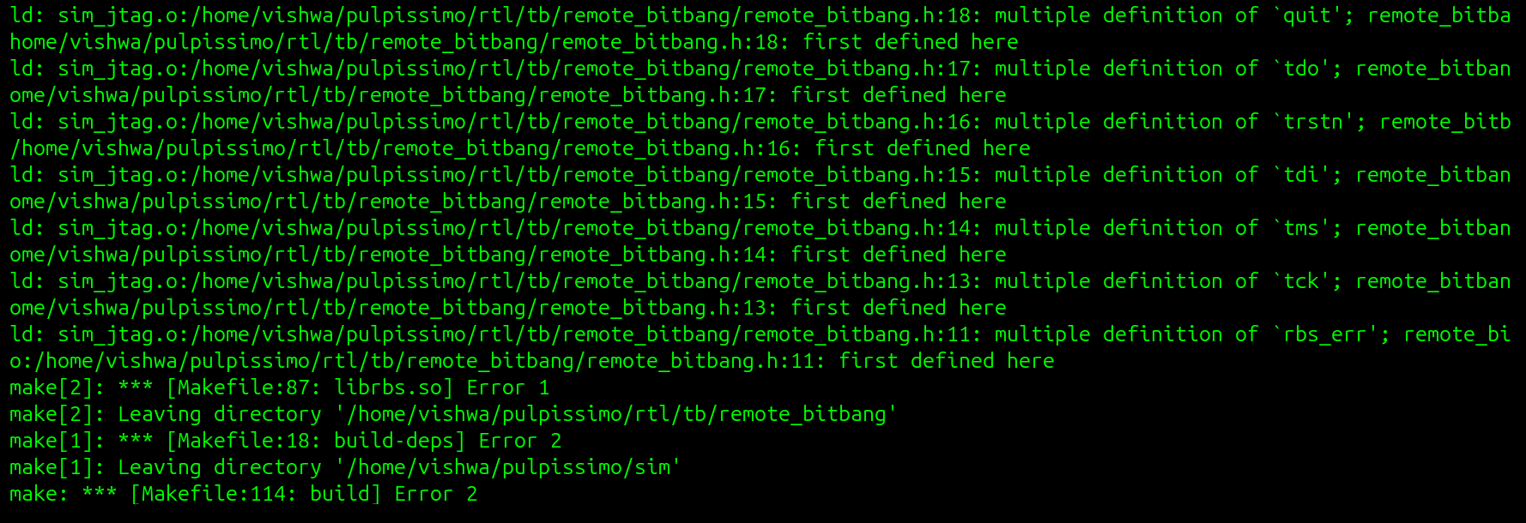

Solution:
Go to the file: <pulpissimo directory> /rtl/tb/remote_bitbang/remote_bitbang.h

extern int rbs_err;

unsigned char tms;
unsigned char tdi;
unsigned char trstn;
unsigned char tdo;
unsigned char quit;

int socket_fd;
int client_fd;

static const ssize_t buf_size = 64 * 1024;
char recv_buf[64 * 1024];
ssize_t recv_start, recv_end;

Change these variables to:

extern int rbs_err;

extern unsigned char tck;
extern unsigned char tms;
extern unsigned char tdi;
extern unsigned char trstn;
extern unsigned char tdo;
extern unsigned char quit;

extern int socket_fd;
extern int client_fd;

static const ssize_t buf_size = 64 * 1024;
extern char recv_buf[64 * 1024];
extern ssize_t recv_start, recv_end;

Error #2)
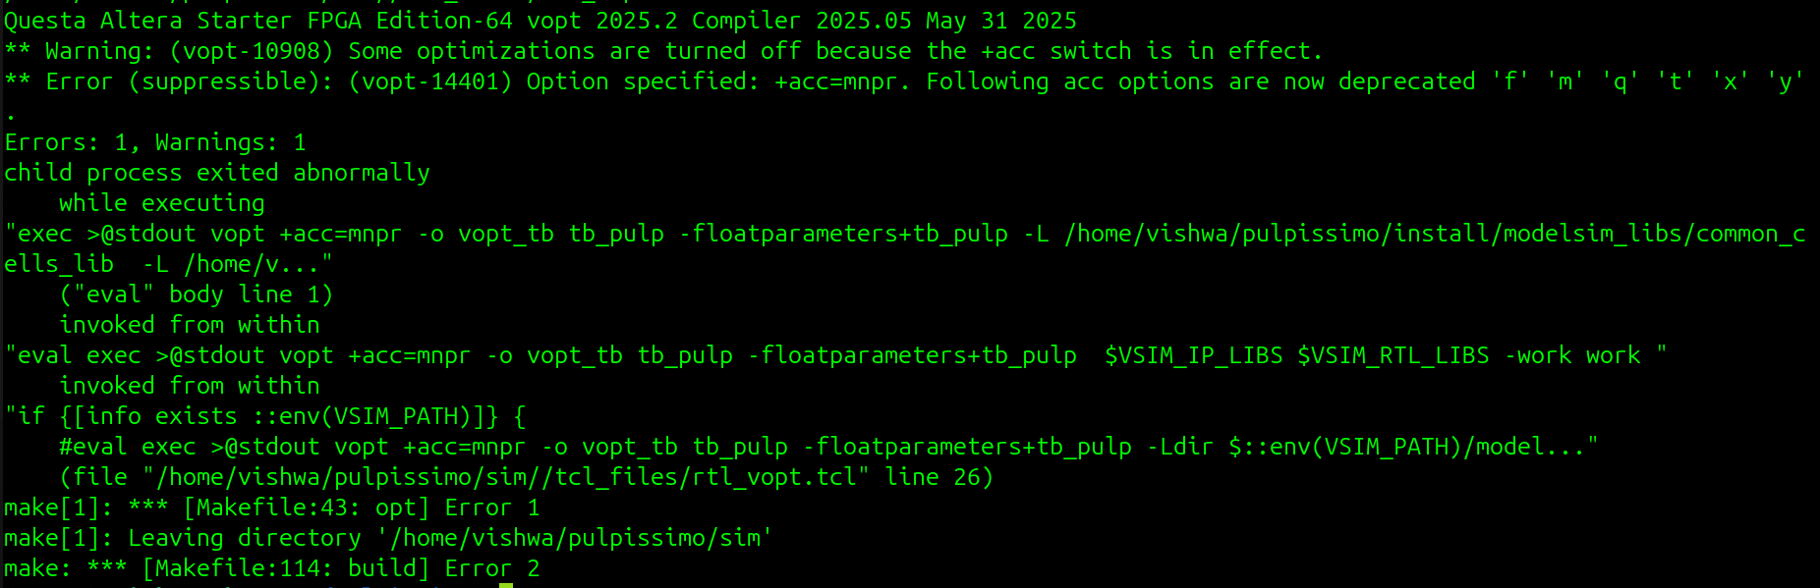

Solution:
edit file: pulpissimo/sim/tcl_files/rtl_vopt.tcl
replace: vopt +acc=mnpr to vopt +acc in line 28 and 30

Error #3).
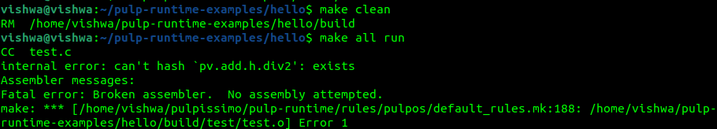

Solution:
Edit file:~/pulp-runtime-examples/hello/Makefile

Replace:
PULP_APP = test
PULP_APP_SRCS = test.c
PULP_CFLAGS = -O3 -g

# Workaround for XPULP assembler crash:
# "internal error: can't hash `pv.add.h.div2': exists"
PULP_ARCH_CFLAGS = -march=rv32imc -DRV_ISA_RV32
PULP_ARCH_LDFLAGS = -march=rv32imc
PULP_ARCH_OBJDFLAGS = -Mmarch=rv32imc

include $(PULPRT_HOME)/rules/pulp.mk
include $(PULP_SDK_HOME)/install/rules/pulp_rt.mk

